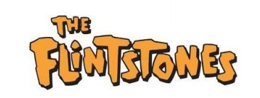Published by: Fred Flintstone (anyone)

c/o 151 Bedrock Avenue

BigRock, South Dakota 50001

10/26/23

**HOUSE GOVERNANCE STRUCTURE DECLARATION**

ESTABLISHMENT:

The House of Flintstone was organized and declared to exist under a New Creature, Spiritual Name, on February 10, in the year of our Lord, 2015.

TYPE OF GOVERNANCE:

The House of Flintstone operates as a governance that indentures its members to the Kingdom of God by legislation created and agreed to by the members of the House. Acts, Declarations, Proclamations, and Resolutions are made and agreed to by the Council of the House of Flintstone. These true indentures are then observed contractually by the members of the House of Flintstone.

I testify that the statements above are true and correct and represent the true nature of the governance of the House of Flintstone and its holy structure.

MEMBERS

-----------------------------------

Spiritual Flintstone, Overseer

------------------------------------

First-Middle: Last, Member 1

------------------------------------

First-Middle: Last, Member 2

------------------------------------   
First-Middle: Last, Member 3